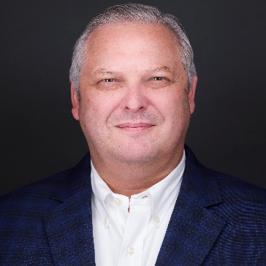
Scott Myers
Principal
Tunnell Consulting
Scott.Myers@TunnellConsulting.com

Scott Myers is an accomplished executive in the pharmaceutical and biotechnology sectors, bringing over 30 years of experience in Quality, Compliance, Operations, and Business Leadership. He is currently a Principal at Tunnell Consulting, where he leads transformative initiatives for clients in cell and gene therapy, biotech, and emerging pharma, specializing in regulatory readiness, operational scaling, and quality systems development.
Scott has a distinguished track record managing large-scale compliance programs, including Consent Decree remediation, international regulatory inspections (FDA, EMA), and global product launches. Prior to joining Tunnell, he held senior leadership roles at Boehringer Ingelheim subsidiaries, where he was instrumental in establishing launch operations, directing multi-site quality laboratories, and managing third-party partnerships.
Throughout his career, Scott has been recognized for his ability to drive results in complex, highly regulated environments while maintaining a strong focus on risk management, quality excellence, and cross-functional collaboration. His technical foundation as a licensed pharmacist, combined with his commitment to operational excellence and continuous improvement, makes him a respected advisor and mentor.
Scott has a BS in Pharmacy from the Philadelphia College of Pharmacy and Science and is a Registered Pharmacist.
In his free time, Scott is busy with his family and friends enjoying sharing the output his backyard grill and smoker!
Scott has been an active member of PDA since 2012 and a PDA Midwest board member since 2018.

